
How to File Financial Reports Online

Last Updated: Wednesday, February 8, 2023
The content of this document is confidential and a proprietary trade secret. It is therefore not subject to open disclosure under Florida Public Records laws.
This document is provided solely for the use of licensed users of Voter Focus and Web Focus. The content, in whole or in part, is not to be disclosed to any unauthorized person.
The information in this document is subject to change without notice. No part of this document may be reproduced or transmitted in any form or by any means, electronic or mechanical, for any purpose, without the express written permission of VR Systems Inc.
© 1995-2023 VR Systems Inc. All rights reserved.

Distribution Notice

Counties, Please Note Before Distributing this Document
You are welcome to use all or part of this document in preparing documentation for distribution to political candidates or committees. However, if you choose to omit our copyright statement and/or footers stating that the information is proprietary and confidential, please insert the following text as a preface to any documentation containing material from this document. Note that you will need to insert your county’s name in the text.
This document was prepared in part using material provided to <your county name> County by VR Systems Inc. Such material is confidential and a proprietary trade secret. The software is also a proprietary trade secret. Software and software documentation are therefore not subject to open disclosure under Florida Public Records laws.
If you have questions about this matter, please contact us.

CONTENTS

Distribution Notice
Online Financial Report Overview Create Reports Online
Getting Started
Password Reset 10
Campaign Financial Reporting System Main Page
Time Periods When Financial Reports are Required 12
Current Reporting Period Diagram The Command Buttons
View and Maintain Contributions
Add a New Contribution 17
Add a New Expenditure
About Petty Cash 20
Add Contributions and Expenditures Overview 23

VR Systems Confidential/Proprietary Trade Secret

Preview a Report Record a Distribution Transfer Funds
Import Data from Campaign Application
Import File Requirements 31
Current Reporting Period 31
Past and Future Reporting Periods 33
Submit a Report
Instructions for Filing a Paper Report 34
Instructions for Filing by Electronic PIN 34
Submit Paper Reports 35
Submit Electronic Reports 37
Review a Submitted Report 41
Confirm the Report is Available on the Website 42
Save A Copy Of The Report 44
Change a Filed Report 45
Remove an Amended Report 48
Change or Delete an Item on an Original Report 49
Submit a Waiver 52
Unlock a Report 55
Export Data to a Spreadsheet Campaign End Reporting Update Candidate Photo and Bio
Upload a Photo 61
Enter Candidate or Committee Text 62
After Your Updates 64

CONTENTS | VR Systems Confidential/Proprietary Trade Secret 5

Reset Password
Change a Password or PINs 66

Log Out of the System

CONTENTS | VR Systems Confidential/Proprietary Trade Secret 6

Online Financial Report Overview
As you know, Florida law requires that candidates and political committees file monthly reports with the Supervisor of Elections. These reports detail all contributions received and expenditures made by or on behalf of the candidate/committee. The Voter Focus Campaign Financial Reporting system gives campaign treasurers an easy way to complete and, optionally, file these required reports, online.
Each report generated by the Campaign Financial Reporting system is a PDF file that can be viewed in Adobe® Acrobat® Reader. The PDF can be printed if your county requires hard- copy filing. In counties that accept electronic filing, the PDF can be submitted online, signed by the candidate’s and treasurer’s electronic personal identification numbers (PINs).
Once a report is accepted by the Supervisor of Elections, it appears on the elections website and can be viewed by the public. Along with the financial reports, you have the option of providing a short description (or “bio”) of the candidate/committee and a photograph.
Here’s an example of a monthly report. First, there’s a summary page.
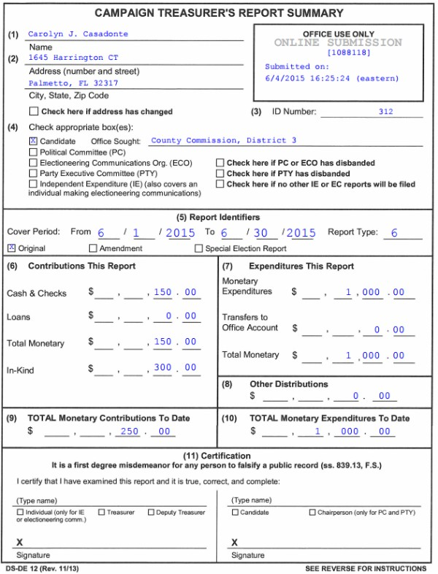
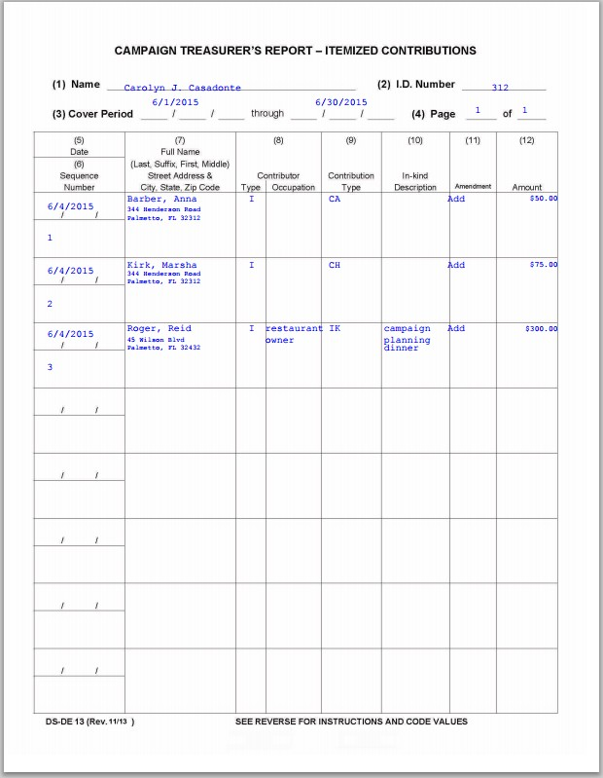

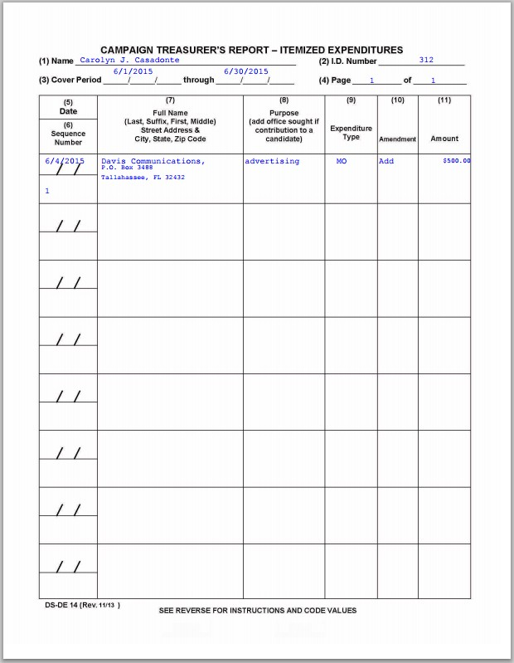

After the summary are itemized lists of contributions, expenditures, and then distributions.
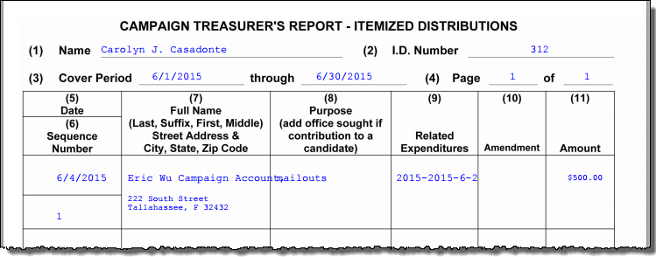

The last listed are fund transfers.
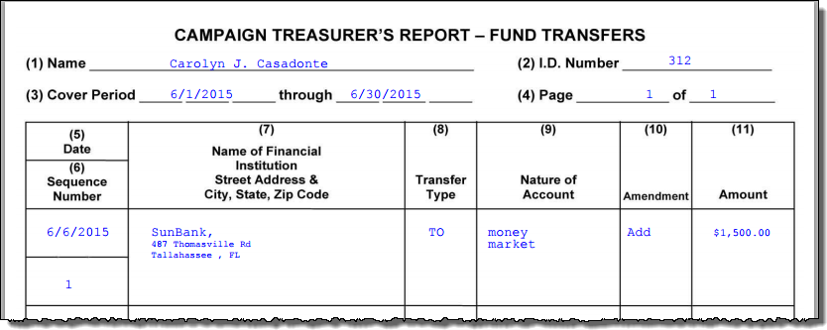

Create Reports Online
To create reports online, you must have access to:

- A computer equipped with:
  - An Internet connection.
  - A web browser configured to accept cookies and with pop-up blockers disabled. In this document, the examples shown use Internet Explorer.
  - Adobe® Acrobat® Reader, which you will need to view and print your reports. If you don’t have the Reader software on your computer, you can download it free of charge from www.adobe.com.
  - A connected or networked printer, if your county requires you to file a hard copy of the report or you want a hard copy of the report for your records.
- A candidate ID and password. This will be provided to you by the elections office.
  - Candidates need a new ID each time they run for office, even when they are running for reelection to the same office. Committees also need a new ID for each election.
  - Committees of continuous existence typically can keep the same ID, but this varies from county to county. Some counties prefer to assign committees of continuous existence a new ID for each election.
  - The password can be changed after you log in. See Change a Password or PINs for instructions.
- PINs for the candidate and campaign treasurer password.
  - If your county permits electronic submission of financial reports, two 4-digit PINs will be provided to you by the elections office. You can change the PINs after logging in. See Change a Password or PINs for instructions.
Your county might have other requirements, so check with the elections office before you begin.

Getting Started

Important: Log in to only one instance of the Campaign Financial Reporting system in your browser. Having the system open in multiple browser windows at the same time can cause undesirable results.

Log in to the Campaign Financial Reporting system.

- Type the following web address into your browser: https://www.voterfocus.com/ws/WScand/candidate_pb.php?county=<county>
Replace the text <county> with your county name. You can enter lowercase or uppercase letters.
For example, if your county is Holmes, you would enter: https://www.voterfocus.com/ws/WScand/candidate_pb.php?county=holmes
- Press the Enter key on your keyboard. You’ll then see the Candidate Log In page:
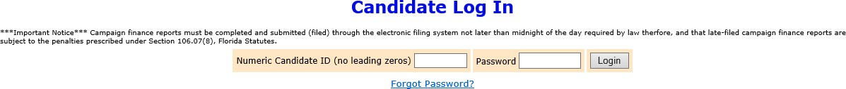

- Enter your candidate ID and password.
The password is case-sensitive. That means you have to enter the password in exactly the form given to you by the elections office: if a letter is uppercase, you must enter it in uppercase; the same goes for lowercase letters. Your password might also have numbers.
Note: You can change your password once you log in. See Change A Password or PINs for more information.
- Click Login.

Password Reset
Your county may require that you change your password the first time you log in. If that is the case, after you click Login, you will see the Candidate Reset Password page:

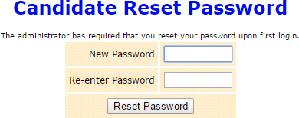

- Enter a password in the New Password field, and then enter the same password in the Re-enter Password field to confirm your entries match.
Passwords must meet the following requirements:
  - Must be more than 8 characters in length.
  - Cannot be the current password.
  - Cannot be password.
  - Cannot include any county name.
  - Cannot be commonly used phrases or passwords.
- Click Reset Password.
- On the Candidate Log In page, re-enter your candidate ID and your new password and click Login.

Campaign Financial Reporting System Main Page

The main page of the Campaign Financial Reporting System that displays when you log in is called the Report List. It shows the reporting periods for the campaign and the following information:
  - Election
  - Your candidate ID
  - Office or issue
  - Your name
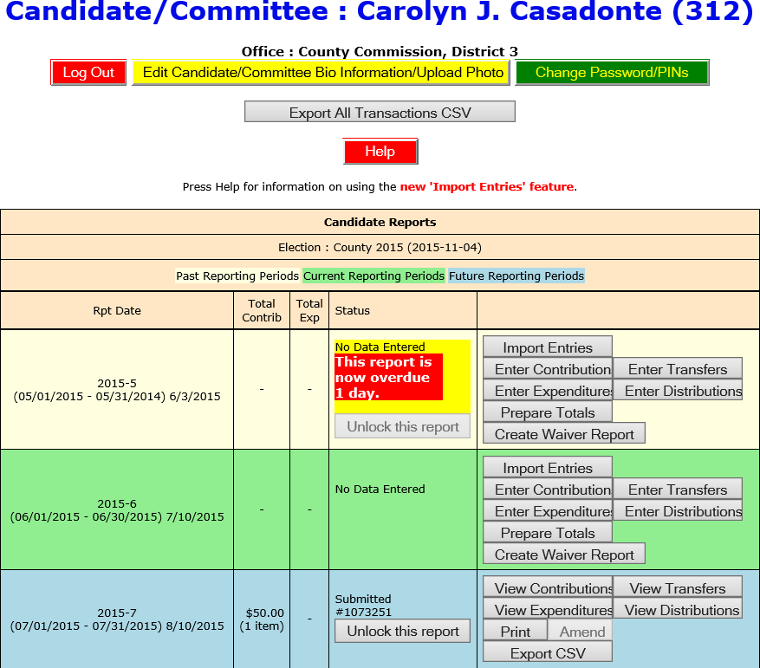

Time Periods When Financial Reports are Required
Colors indicate reporting periods:
(beige)
(green) (blue)

The reporting periods are color-coded to help you choose the correct period for reporting data.
The past and future reporting periods are locked to prevent you from inadvertently entering current data into a past or future report. If you need to enter past or future data, you can easily unlock the report by clicking Unlock this report.
The colors of the reporting periods switch automatically at midnight on the due date of the current report.
If any of your reports are overdue or the due date is less than ten days away (that is, nine or fewer days from today), you’ll see a message like this at the top of the page:
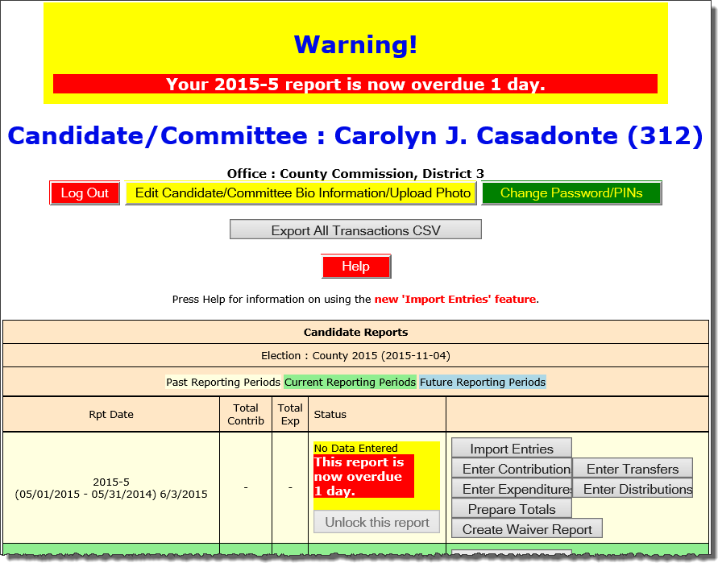

Note: After 180 days, overdue reports are no longer highlighted as late. And the due/overdue report(s) are highlighted as well.
If a report is overdue, you must take immediate action to file the report.

Current Reporting Period Diagram

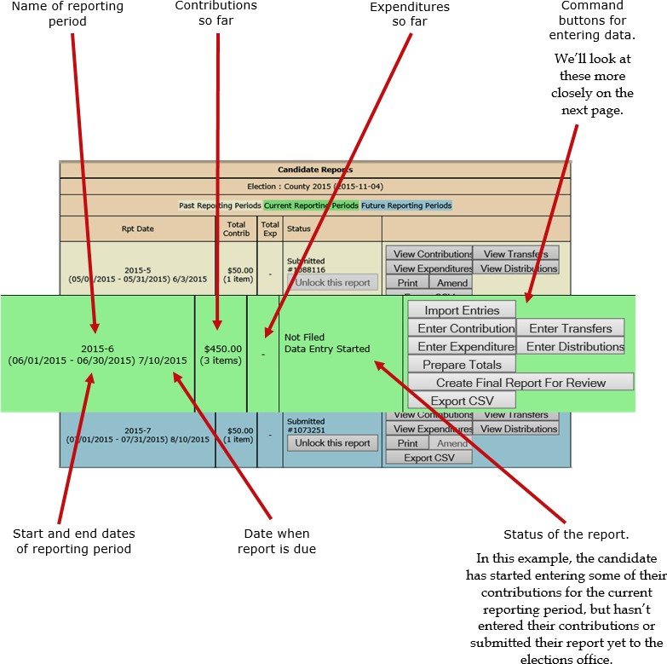

The Command Buttons

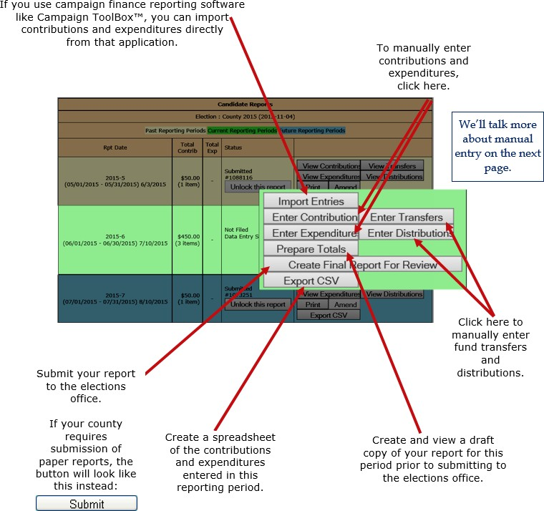

View and Maintain Contributions

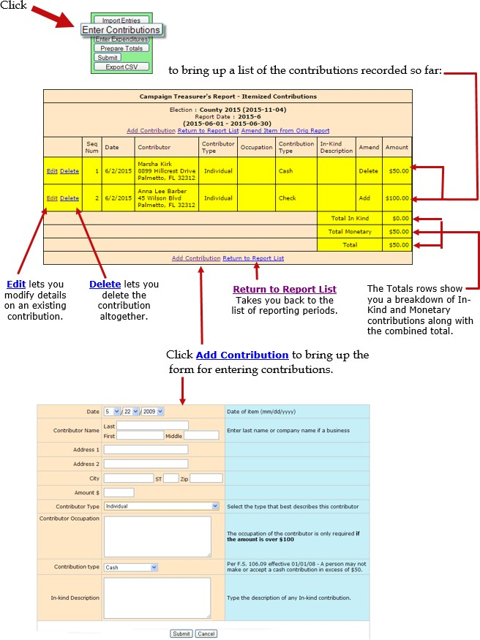

Add a New Contribution
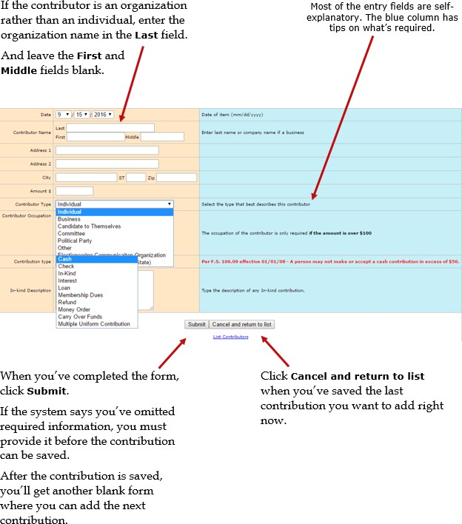

The Contribution Type should be one of these:

Carry Over Funds | Remaining “carry over funds” from an election that has ended.  This option is for use by candidates only.
Cash | Cash or cashier's check.
Check | Traditional paper check, wire transfer, PayPal, credit card, or another type of electronic funds transfer.
In-kind | An item of value other than money or volunteer services.  In-kind Description: Enter a specific description of the in-kind contribution. Example: Food and beverage
Interest | Money earned on campaign or interest-bearing accounts.
Loan | Money loaned to the campaign rather than given outright.

Membership Dues | Membership dues regardless of the form (cash, check, etc.).
Money Order | Contribution made by money order.
Multiple Uniform Contributions | Multiple uniform contributions from the same person  This option is for use by committees only.
Refund | Bad checks or contributions returned (in whole or in part) to the contributor.  Refunds must be entered as a negative amount.

Add a New Expenditure

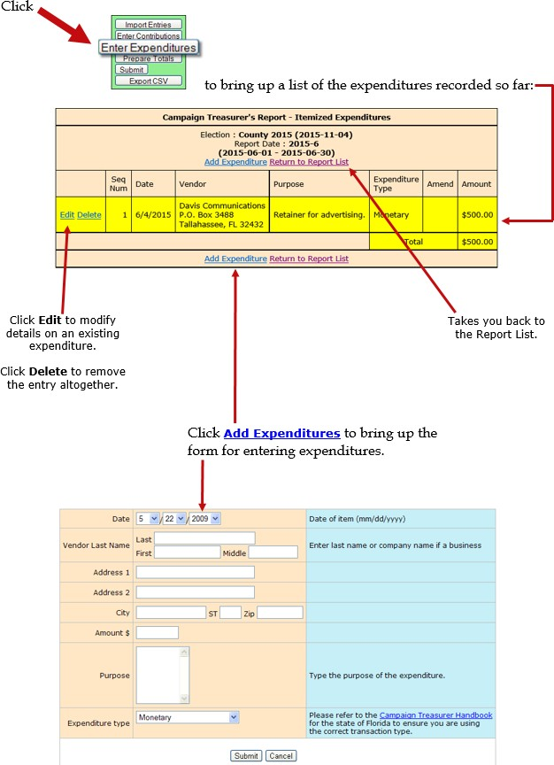

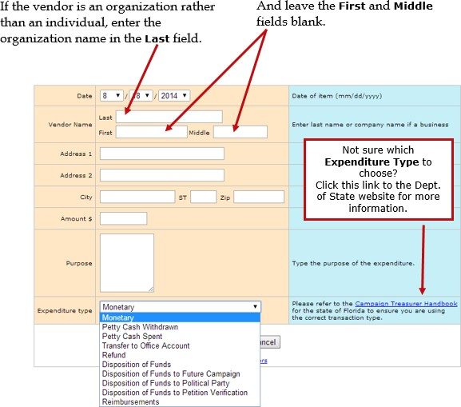

About Petty Cash
In Expenditure Type, notice that there are two types for petty cash:

- Use Petty Cash Withdrawn when withdrawing funds from the campaign account for petty cash. This will add an expenditure of the entered amount to your report.
- Use Petty Cash Spent to record an expense out of petty cash.
- Petty Cash Spent does not add an expenditure to the report because the expenditure was already recorded as Petty Cash Withdrawn.
It’s important to keep accurate petty cash records so your final report will balance. When you’ve completed the form, click Submit.
After the expenditure is saved, you’ll get another blank form where you can add the next expenditure.
Click Cancel when you’ve saved the last expenditure you want to add. The Expenditure Type should be one of these:

Disposition of Funds | Pro-rata refunds to contributors, donations to charitable organizations, donations to the State general revenue fund, or the return of matching funds to the State.  Disposition of Funds expenditures are for use by candidates only and are only used on Termination Reports. They are not part of the Monthly Total Monetary amounts.
Disposition of Funds to Future Campaign | Funds transferred to an account for a future campaign.  Disposition of Funds expenditures are for use by candidates only and are only used on Termination Reports. They are not part of the Monthly Total Monetary amounts.
Disposition of Funds to Petition Verification | Funds transferred to pay for previously unpaid petition verification fees.  Disposition of Funds expenditures are for use by candidates only and are only used on Termination Reports. They are not part of the Monthly Total Monetary amounts.
Disposition of Funds to Political Party | Funds given to the political party that the candidate is a member of.  Disposition of Funds expenditures are for use by candidates only and are only used on Termination Reports. They are not part of the Monthly Total Monetary amounts.
Monetary | General expenditure type used when a specific type does not apply.
Petty Cash Spent | Petty cash spent during a reporting period.  Expenditures made from petty cash are not required to be reported individually.
Petty Cash Withdrawn | Petty cash withdrawn during a reporting period.  Petty cash expenditures are realized when the funds are withdrawn for petty cash. Therefore, the referenced item is not included in the total.
Refund | A refund of money from a vendor or other source.  Refunds must be entered as a negative amount.

Reimbursements | Compensation made to a person or group by a check drawn on the campaign account for expenses incurred in connection with campaign activities.
Transfer to Office Account | Funds transferred to an office account when the candidate has been elected.

Add Contributions and Expenditures Overview
If you enter a contribution or expenditure outside of the range of the reporting period you are working with, they system will automatically try to find a reporting period that contains that date you are reporting.
If a report for that range is found, the system will let you know.

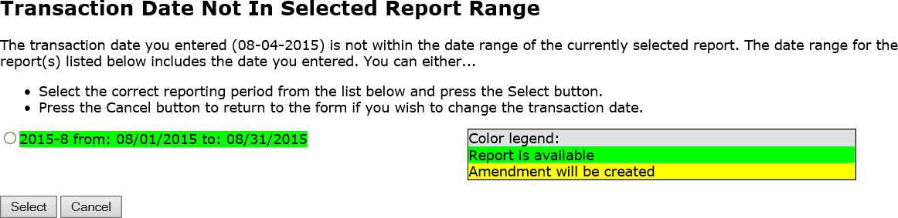

Click the report that you would normally have filled the transaction under, and then click

Select.
If the contribution or expenditure date falls within the date range of a report that has already been filed, you can add the contribution or expenditure to the report and file an amended report in one easy step.

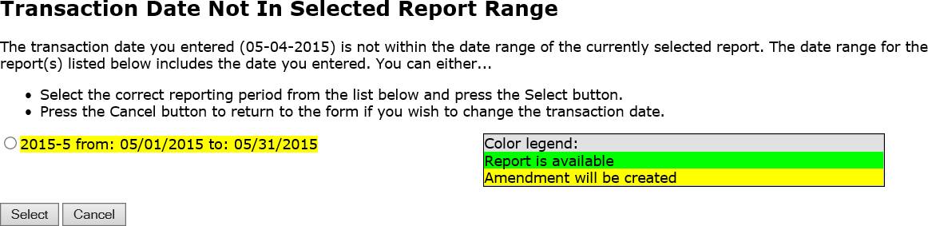

Click the report that you would normally have filled the transaction under and then click Select. A confirmation message will appear letting you know that the amended report has been filed.
If no report exists that includes the date you are trying to report, the system will let you know that too.

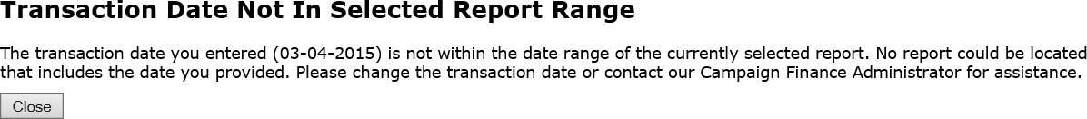

Click Close and either change the transaction date or contact your county Campaign Finance Administrator for assistance.

Preview a Report
Previewing of reports isn’t required. But it’s a good idea to preview the report before you submit it, to catch any data entry errors, missing transactions, or other anomalies.
You can preview a report as many times as you like, make changes, and preview it again until you are confident it is correct and complete. Then you can submit the finished report to the Supervisor. Once a report has been submitted, it cannot be changed, so you want to be sure you preview each report carefully.
Important: Previewing a report DOES NOT submit the report to the Supervisor.
To preview your report at this point, click Prepare Totals (shown below) to open the Prepare Totals page.
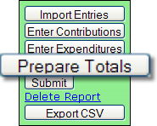
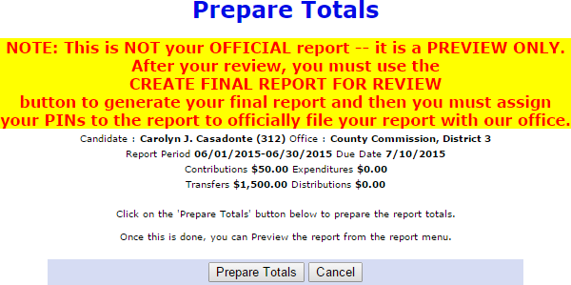

Click Prepare Totals on the page to total the contributions and expenditures for this reporting period. You are returned to the Report List, which now has a banner like this:
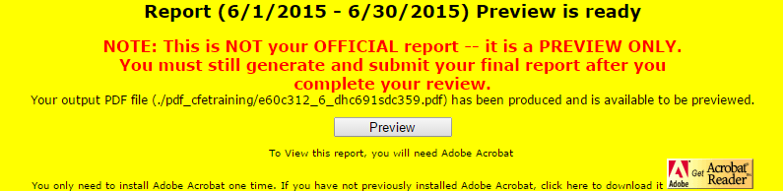

Note: If you haven’t installed Acrobat Reader on your computer, you must do it now. Click the Acrobat Reader icon to go to the download site.
Click Preview in the banner to open your report in PDF format.

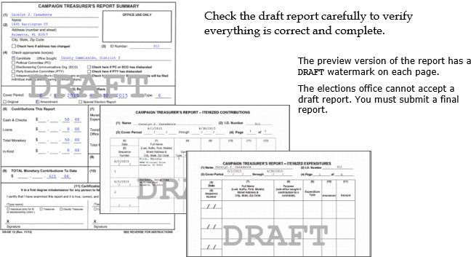

Tip: Forgot to add a contribution or expenditure? That's OK! You can continue to add them after your preview.
On the Report List, notice that the Prepare Totals button is now labeled Preview.
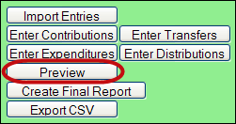

Click Preview at any time to display the report. If transactions are added, the button label returns to Prepare Totals, which means you need to total the new transactions in the report before you can preview it again.

Record a Distribution
A transaction is a distribution only if it is a:

- Credit Card Payment—Linked to the expenditure that represents payment of the credit card bill on which the purchase appears. Only statewide candidates may use this type of distribution.
Each purchase made with the credit card will be itemized under and linked to the expenditure that represents payment of the credit card bill on which the purchase appears. The credit card may be used only for travel-related expenses.
- Prepaid Distribution—Reserved for up-front, lump sum payments to be disbursed to different entities at a later date. (For example, payment to a media consultant who then makes disbursements to newspapers and television stations.) Related entries under will be reported and linked to the expenditure as they occur.
- Reimbursement—Reimbursement for authorized expenses made in connection with the campaign. (For example, Candidate Smith paid for printing of campaign signs with his own money. A check to reimburse him for the cost would be recorded as a Reimbursement.)
Distributions do not add to your report totals. They are used only to report pro-rata amounts of an already recorded expenditure to provide detail for:
- Refunds to contributors
- Donations to charitable organizations
- Contributions to political parties
- Donations to the State general revenue fund
- Return of matching funds to the State.

To record a distribution:

- Click Enter Distributions (shown below) to open a page with descriptive requirements for a distribution transaction.

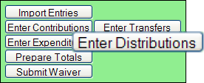

- Then click Proceed with Distribution to see the following page:
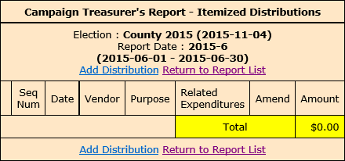

- Click Add Distribution to open the form used to enter distributions.
- If the entity receiving the distribution is an organization rather than an individual, enter the organization name in the Last field.
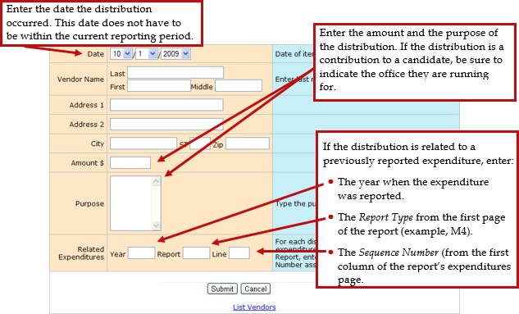

- When you complete the form, click Submit to save the information. After the distribution is saved, a blank form opens to enter another distribution.
- Click Cancel after you save your last distribution. You’ll see the distributions you added highlighted in yellow, as in this example.

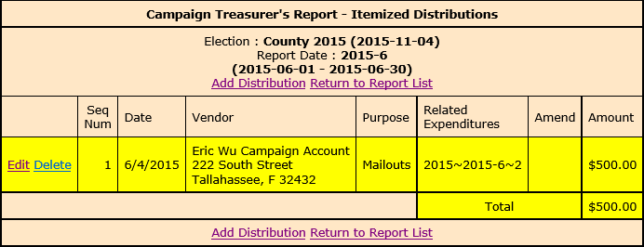

Transfer Funds
Fund transfers are typically used only by candidates for state and federal offices. They are used to report the transfer of funds between the primary depository and separate interest- bearing accounts.
- Click Enter Transfers (shown below) to open the Itemized Fund Transfers page.
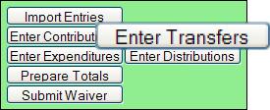
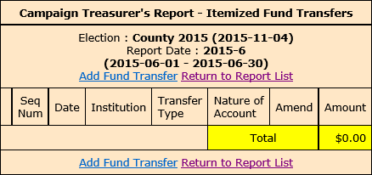

- Click Add Fund Transfer to open the form used to enter transfers.
- Enter the financial institution where the account is held.
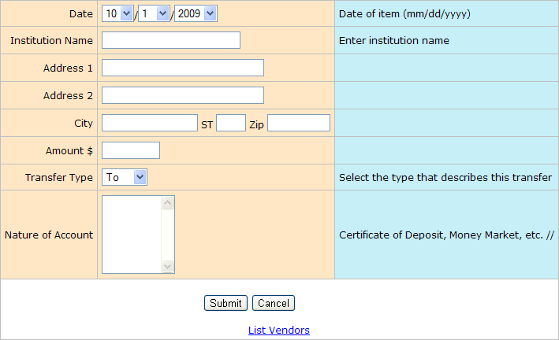

- Select one of the following:
  - To, if the transfer is from the campaign account to the institution account.
  - From, if the transfer is from the institution account to the campaign account.
- When you complete the form, click Submit to save the information. After the transfer is saved, a blank form opens to enter another transfer.
- Click Cancel after you save your last transfer. Transfers are not shown on the Reports List because the funds are simply moved within the campaign or committee, rather than expended or distributed elsewhere.

Import Data from Campaign Application

Import File Requirements
The system can import any file that meets the Division of Elections Campaign Finance Reporting File Specifications:
Dos.myflorida.com/elections/candidates-committees/campaign-finance/filing-campaign- reports/
For a list of State-approved software vendors for electronic filing, see:
Dos.myflorida.com/elections/candidates-committees/campaign-finance/filing-campaign- reports/vendors/
Candidates or committees using campaign finance reporting software, such as Campaign ToolBox™, can import contribution, expenditure, distribution, and fund transfer data from a file created by the application directly into the Campaign Financial Reporting system.
When you import data from a file, the transactions are added to the report you are working in. Be sure to review the report prior to submission to verify the data matches what you intended to import and make any adjustments manually.
Important: When you import a file from your campaign finance reporting software, if there are existing entries in the Campaign Financial Reporting system for the reporting period you are importing entries in to, these entries will be replaced with the information from your file.
Note: Before importing a file, verify that you have not manually entered contributions, expenditures, distributions, or fund transfer data into the Campaign Financial Reporting system. If so, verify that these entries also exist in your campaign finance reporting software.

Current Reporting Period
To import data for the current reporting period:

- On the main page, locate the row for the current reporting period (look for the green row) and click Import Entries.

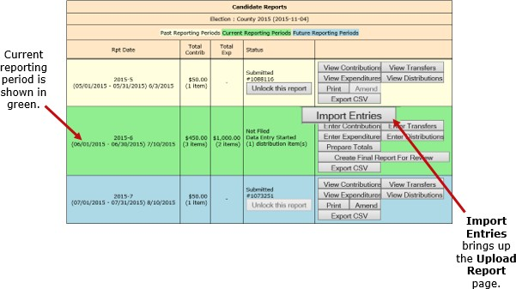

- On the Upload Report page, click Browse, locate the file to import, and click Upload Report.
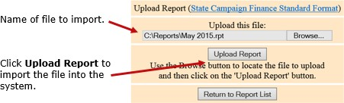

You’ll see a display of the transactions imported from the file, as in this example:
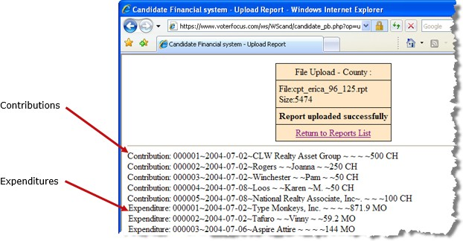

- When you finish importing entries for the reporting period, preview and submit the report.

Past and Future Reporting Periods
  - Past reporting period—If you already submitted the report for the past reporting period, you’ll need to unlock it and create an amendment. Then you’ll need to unlock the amendment and follow the Import Entries instructions in the previous procedure.
  - Future reporting period—Unlock the reporting period and follow the Import Entries instructions in the previous procedure.

Submit a Report
Important: Make sure you have entered ALL contributions and expenditures correctly before you click Submit Report. Clicking Submit Report closes the report.
Once you do this, the report cannot be changed, although it can be amended. See Change a Filed Report for more information.
The steps you take to submit a report depend on whether your county requires a hard copy of the report signed by the candidate and treasurer or requires submission of reports “signed” by the electronic PINs of the candidate and treasurer.

Instructions for Filing a Paper Report
"Submit Paper Reports" on the next page

Instructions for Filing by Electronic PIN
"Submit Electronic Reports" on page 37

Submit Paper Reports
(If your county requires electronic reports, skip to "Submit Electronic Reports" on page 37.) Submitting a report does the following:
  - Removes the DRAFT watermark from the report pages.
  - Seals the report: you cannot add, change, or delete contributions or expenditures once you have submitted the report.
  - Files the report online with the elections office. Some counties require you to also provide with elections office with a signed hard copy of the report before your filing is considered complete.
To finalize the report:

- Click Submit to open instructions.
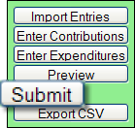

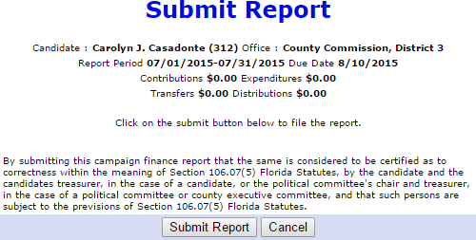

- When you finish your entries for this reporting period, click Submit Report. You return to the Report List with green banners at the top indicating submission.
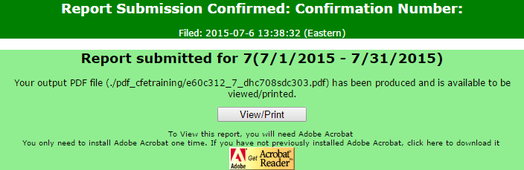

Notice that the report’s status is now Submitted. You’ll also see a confirmation number and the command labels are changed.
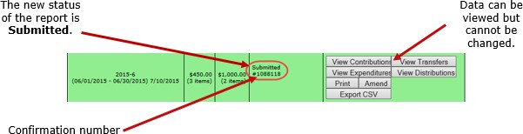

To display or print the report:

- Click Print or View/Print on the banner to open the PDF.
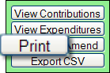

- Sign the report and deliver it to the elections office prior to the deadline for this reporting period.
Note: The report requires two signatures; one from the candidate and another from the campaign treasurer.
If the county has your email address in the administrative section of the Campaign Financial Reporting System, you are automatically sent an email when the Supervisor of Elections accepts or rejects your report.

Submit Electronic Reports
Note: If your county requires paper reports, refer to "Submit Paper Reports" on page 35.

- To finalize the report, click Create Final Report For Review to display instructions.
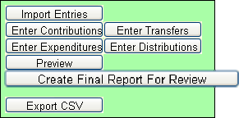
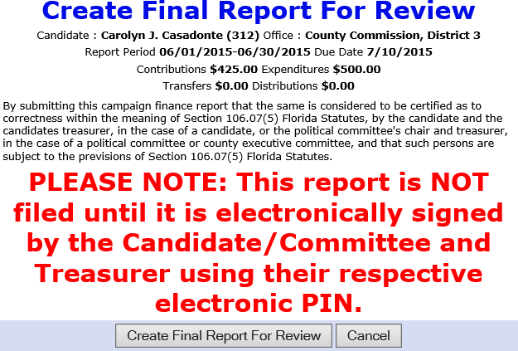

- When you finish your entries for this reporting period and you are ready to file, click Create Final Report For Review. The Electronic Signature PINs page opens with a reminder that the report is not yet submitted followed by an online view of the report.

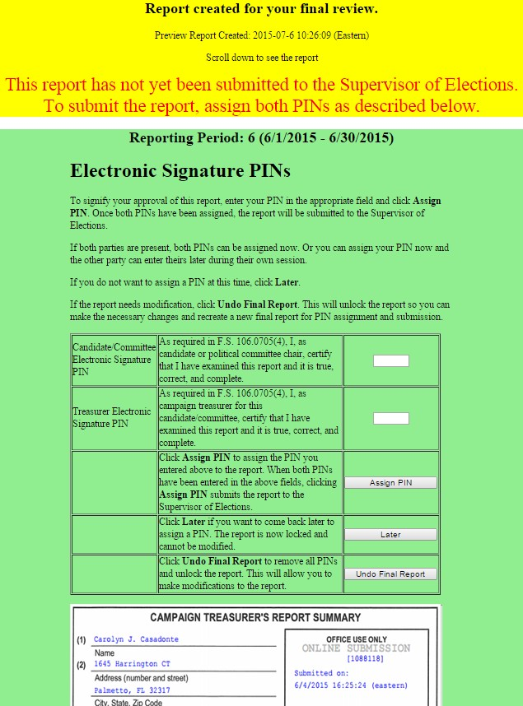

- You can do the following:
  - Enter both PINs in the space provided and click Assign PIN to submit the report to the Supervisor of Elections.

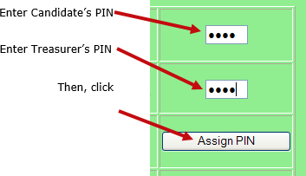

  - Enter just one of the PINs and click Later to return to the Report List.
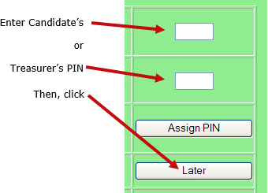

The message Signature (PINs) Required appears in the report’s Status column and the report is then locked, which means no changes can be made.
- When the report is ready to be signed with the other PIN, click Assign PIN(s) to reopen the PIN page.
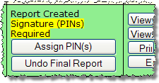

- Enter the missing PIN and click Assign PIN to submit the report to the Supervisor of Elections.

Note: If you want to remove the PINs and unlock the report so you can make changes, click
Undo Final Report.

Review a Submitted Report
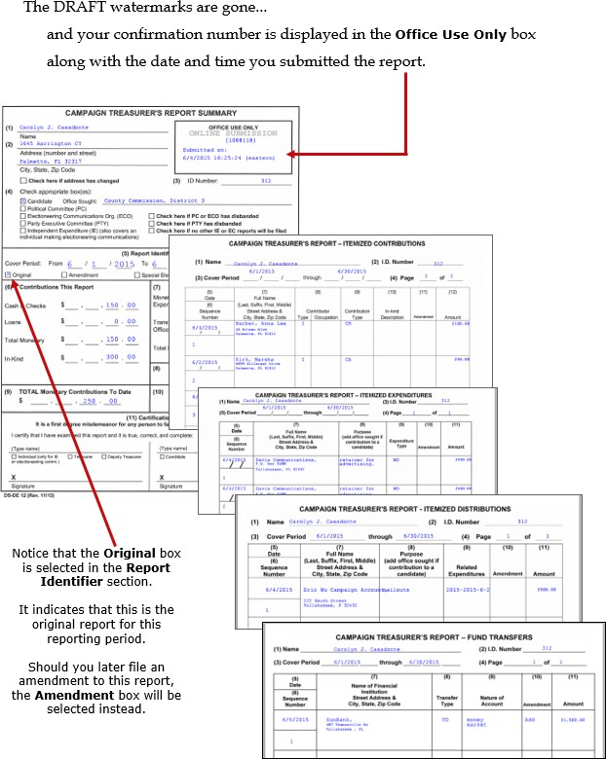

Confirm the Report is Available on the Website
Most counties reserve the right to review reports before releasing them to the public. Typically, when the report status changes to Received, the report is available on the website, but this can vary, so check with your county to find out what you can expect.
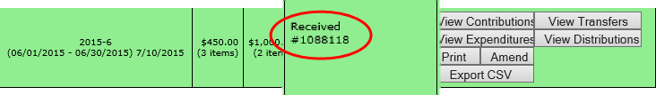

To get to your candidate page, website visitors select your name from the list of candidates running in a selected election. (The elections office will explain how to navigate to this list— it varies by county.)
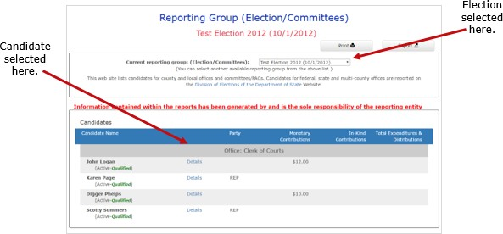

Your candidate page will list all reports that the elections office has released to the website.
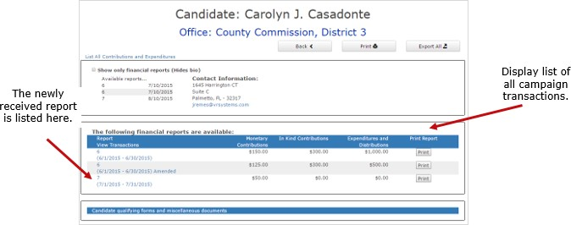

Tip: Did you know a photograph and biographical information can also appear on your page, if you choose to provide them? See Update Candidate Photo and Bio to learn how.
Website visitors can click the report name in the Report Views Transactions column to display a list of all transactions reported so far, grouped by type.

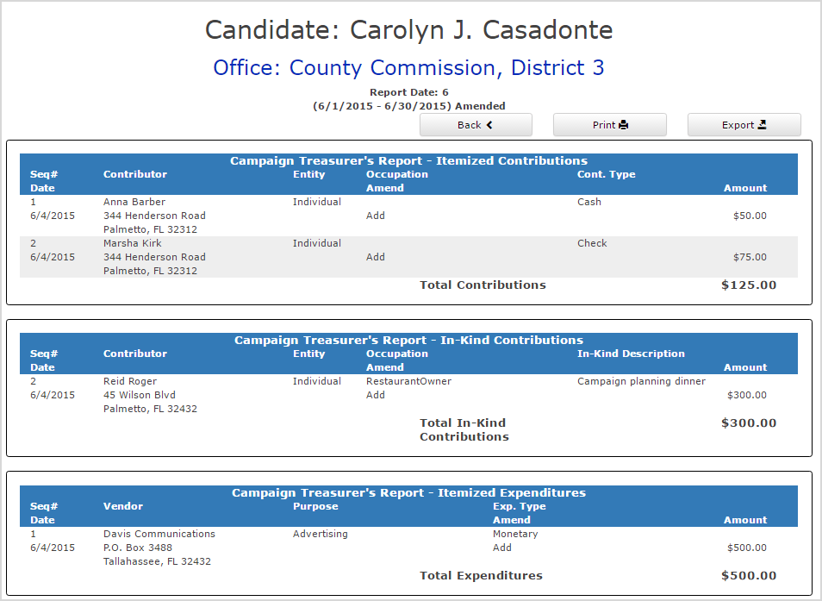

Contributions from persons with protected address status are not shown in reports. Instead, the notation ***Protected*** is shown in place of the address. The Campaign Financial Reporting system scans the county’s voter registration database for voters with protected addresses and automatically redacts those addresses from campaign reports, so they cannot be seen by the public or the Supervisor’s staff. If you are aware of a contributor with a protected address who is not in your local county’s voter database, please advise your Supervisor of Elections.

Save A Copy Of The Report
A copy of all the reports you file will continue to be available on the Campaign Financial Reporting system. If you want to keep a copy for your records, save the PDF to a folder on your computer or network.
To save a copy of the report:

- Click Print to open the report in Acrobat Reader.

- Click  . Save the PDF to a location on your computer or network. You might consider giving the copy a different file name; names assigned by the system are cryptic.

Change a Filed Report
After a report is submitted to the elections office, you cannot change it. But you can make an amendment. An amendment is a separate report for the reporting period. On the amendment’s first page, you’ll see a check mark in the Amendment box. This box is automatically selected when you create an amended report.
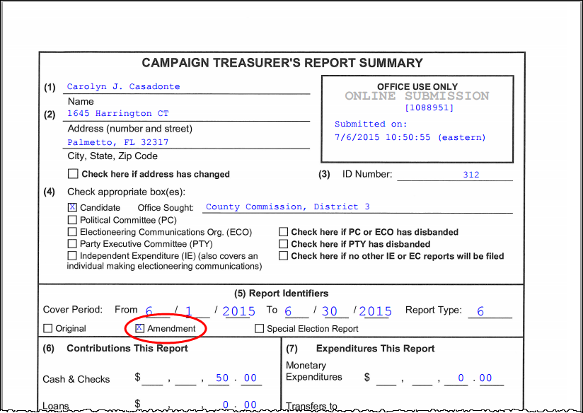

You can amend a report any time after you submit it. When the original report’s status is Submitted, you can add new contributions and expenditures, but you cannot change data on the original report. To change original data, the original report’s status must be Received.
You can create an amendment to a report for any reporting period. The steps to do this are the same for all reporting periods with one exception; for past reporting periods, you must first unlock the report.

Amendment in Current Reporting Period
To create an amendment to a report in the current reporting period:
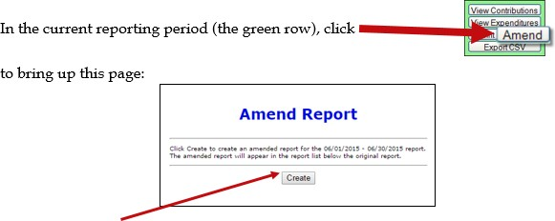

Then click Create.
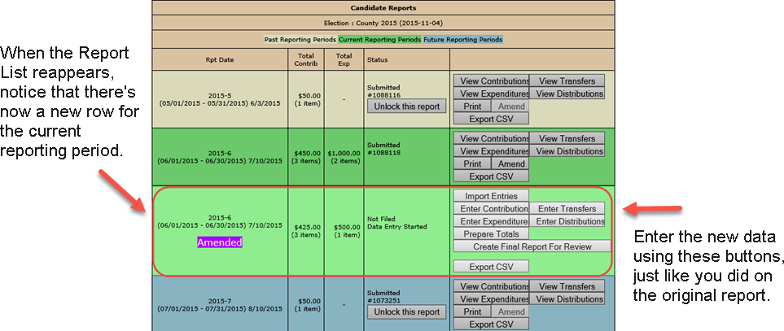

To create an amended report, you can:

- Manually enter new contributions and expenditures.
- Import new contributions or expenditures.
- Change or delete items listed on the original report.
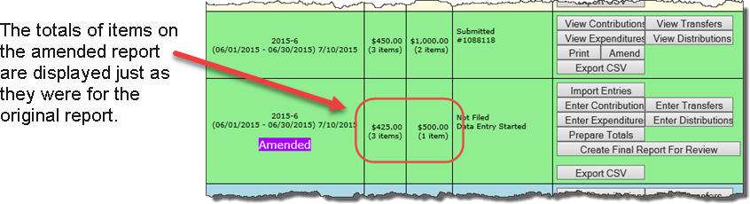

When you are finished entering items, preview the report and submit it to the elections office. You’ll see a new confirmation number for the amendment.
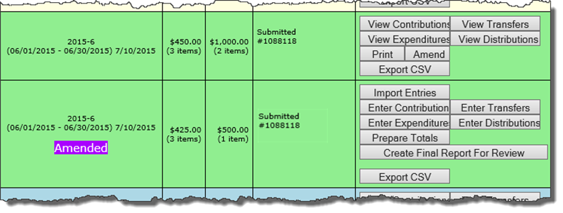

If your county requires a hard copy of amended reports, print the report, sign it, and deliver it to the elections office.
If you need to change a report after submitting the amendment, talk to the elections office. Some counties require a second amended report. Other counties have different procedures.

Amendment in Past Reporting Period
To create an amendment to a report in a past reporting period:

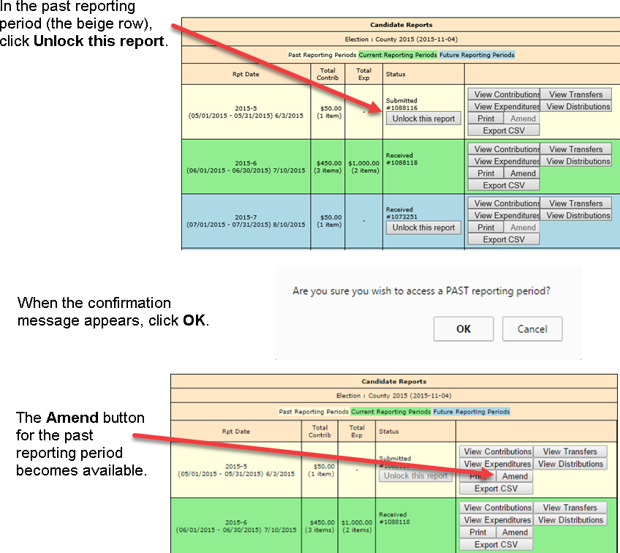

Create an amended report following the instructions for the current reporting period.

Remove an Amended Report

Oops! I didn’t mean to create an amended report!
That happens sometimes.
If you begin creating an amended report, notice that the list of commands on the Report List includes the command Delete Report. To back out of the report, first delete all the transactions you entered for the amended report. Then, once there are no transactions for the amended report, you can click Delete Report to delete it from the system.

Change or Delete an Item on an Original Report
First, verify that the status of the original report is Received.
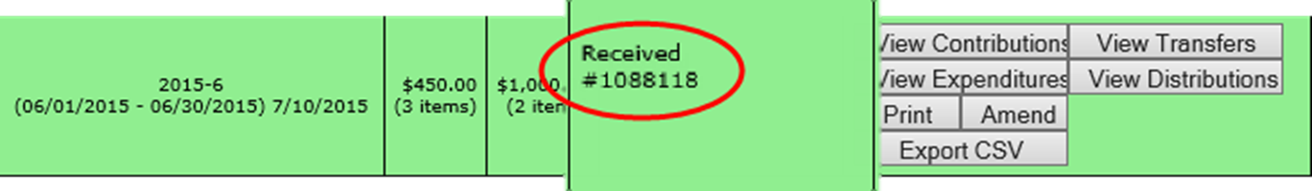

To change data that was entered on the original report, the original report’s status must be
Received.
To change a contribution or expenditure:

- In the current reporting period (the green row), click Amend to display the Amend Report page.
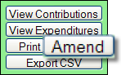

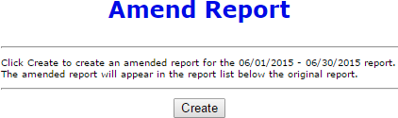

- Next, click Create.
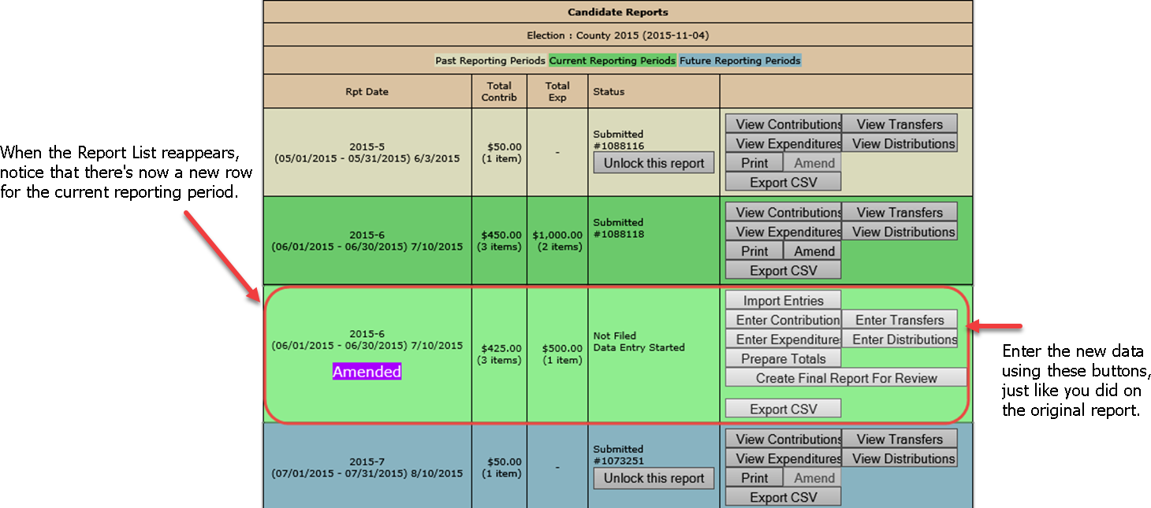
- On the Report List, use any of the buttons as you did on the original report to enter the new data.

- On the next page, click Amend Item from Orig Report to display a list of items (for example, contributions) reported in the current month.
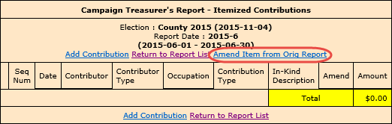

- Highlight the item you want to change and click Amend Item. Detail for that item displays.
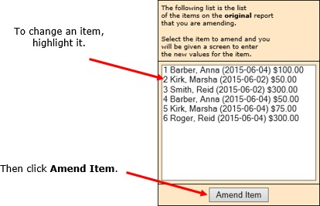

- Make your changes in the appropriate fields and click Submit.
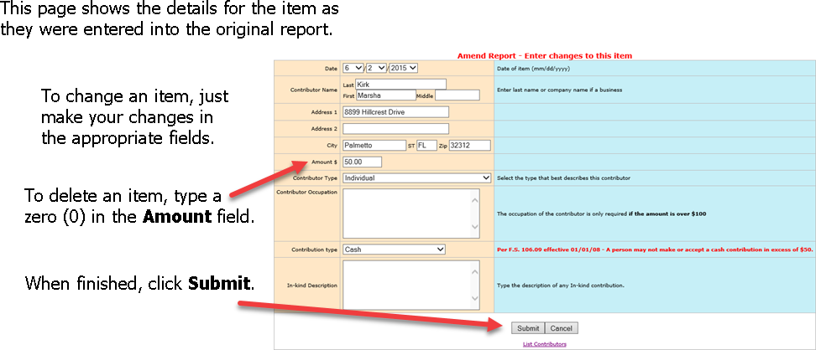

On the next page, you now have two entries (in yellow) representing the changed item:

  - The first entry deletes the item as it was filed in the original report. (Notice the word
Delete in the Amend column.)

  - The second entry adds the item with the changed values. (The Amend column shows
Add.)

In this example, we changed the contribution amount from $50.00 in cash to $100.00 by check.
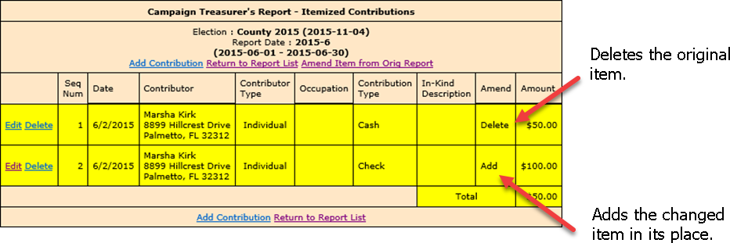

If needed, you can now change another item, add a new item, or return to the Report List.

Submit a Waiver
A waiver is a one page report that you fill out and submit to the elections office to notify there is no activity for a reporting period. In any reporting period when there has been no fund activity (expended or received), filing the report is required.
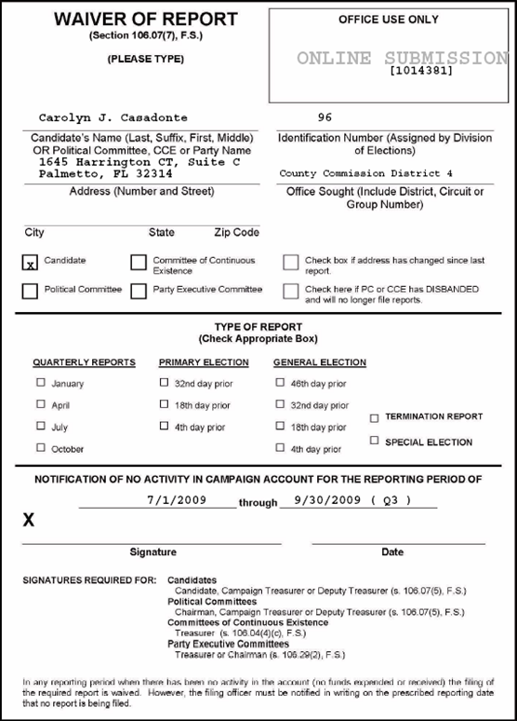

Submit a waiver if your county requires paper reports:
- On the Report List, find the reporting period you want to submit a waiver for. Click

Submit Waiver.

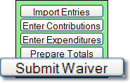

- On the next page, click Submit Report.
You return to the Report List, where you see the confirmation number at the top of the page and the status of Submitted for the report.
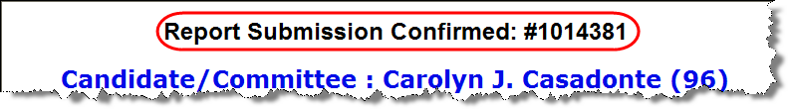
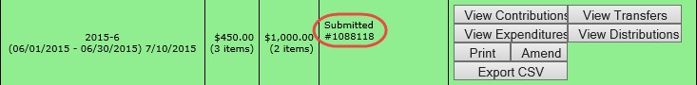

- Click Print to display and print the Waiver of Report.
Note: The Submit Waiver button does not display for committees that are set up as Type - Electioneering Communication.
Some of the fields on the waiver are completed for you. Review it carefully and complete any fields that are not filled out. Then deliver the report to the elections office prior to the reporting deadline.
Waivers can be amended, just like any other report. So, if you later discover you had contributions or expenditures for a reporting period, simply amend the waiver as you would amend any report.

Submit a waiver if your county requires electronic reports:

- On the Report List, find the reporting period that you want to submit a waiver for.
- Click Create Waiver Report.
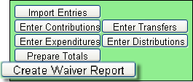

- On the next page, click Create Final Report for Review to open the Electronic Signature PINs page with a reminder that the report has not yet been submitted.
Note: For committees set up as Type - Electioneering Communication, a waiver is no longer generated when clicking Create Final Report for Review with no contributions or expenditures applied.
- Enter both PINs in the spaces provided and click Assign PIN to submit the waiver to the elections office.

Unlock a Report
Have you noticed that reports for past and future reporting periods have an
button?
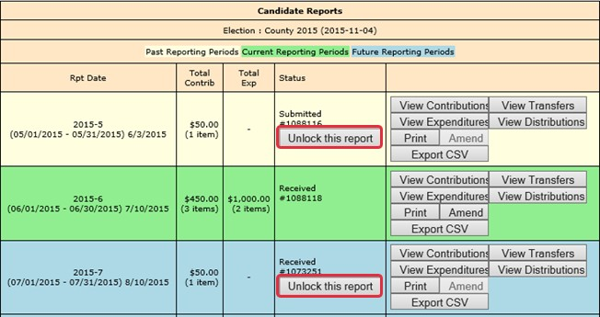
These buttons prevent you from accidentally entering data for the current reporting period in a past or future period.
If you find that you need to amend a past report or enter data for a future report, click

Unlock this report.
For past reporting periods, you’ll then see options for amending the report.
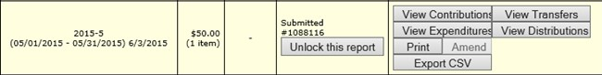

For future reporting periods, you’ll see the usual buttons for entering data.
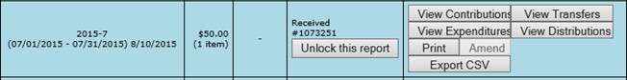

Export Data to a Spreadsheet
The system has two ways to export your financial data to a Microsoft Excel comma-separated values (.CSV) file. The Export CSV option collects all data for the selected report.
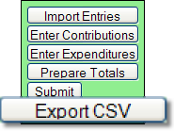

The Export All Transactions CSV collects all data from all reports in the election.
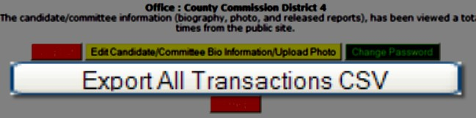

Both options create a file named CFinExport.csv in your C:\Temp folder.
When you click either button, you’ll see a message asking if you want to open or save the file. You can view the file immediately or save it to a different name and location.

The spreadsheet file contains this information:
- Date the item was recorded
- Whether it’s a contribution (C) or an expenditure (E)
- Contributor or vendor name and address
- Contribution type
- Contributor’s occupation
- Item type
- Description
- Amount
- Whether the item was recorded in the original report (blank) or an amendment (A)

Campaign End Reporting
On the Report List, you will see a section for the termination report, which is the absolute last report that will be submitted by your campaign. This report states the financial status of your campaign after all contributions and expenditures have been reconciled. It should also show how any surplus funds were disposed of.
The termination report might not appear in the Report List at the beginning of the campaign, but the elections office will add it to your reporting dates at the appropriate time. Note that it might not be named Termination Report. The elections office can give it any name, such as 2023-Final.
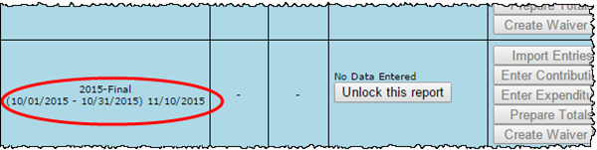

When it’s time to file the termination report, its row is green.
To file this report, you must add any outstanding contributions and expenditures that haven’t been reported in an earlier report.
If surplus funds remain in the campaign account, the termination report should include an expenditure that disposes of those excess funds. When you enter this expenditure, be sure to select Disposition of Funds for the expenditure type.
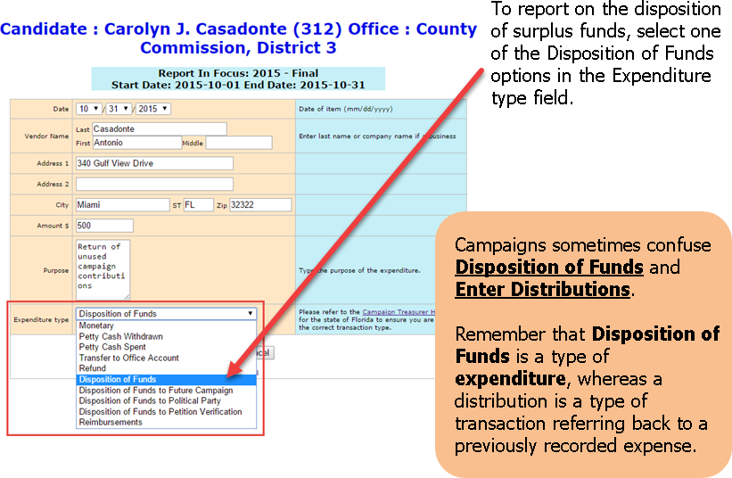

You will see the item listed, but the amount will not be reflected in the total expenditures for the period. Nor will the amount be included on the Report List—in the Total Exp column— although it will be counted as an item. This design is in accordance with Division of Elections requirements.
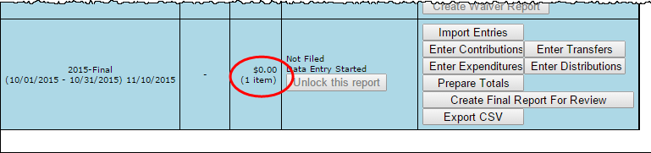

Preview the report and submit it as you have previous reports for the campaign.
When you look at the report, notice that the Disposition of Funds amount is not reflected in box 7 of the Report Summary page.
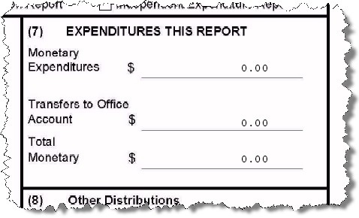

But the amount will be included in box 10 of the Summary Report.
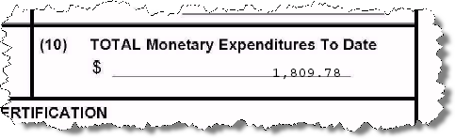

It will also appear on the Itemized Expenditure page with an expenditure type of DI.

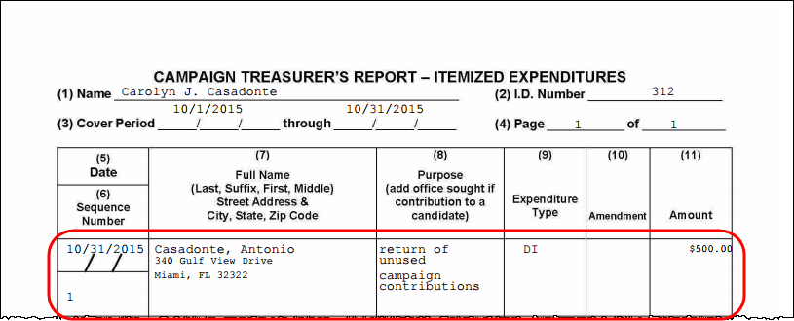

Update Candidate Photo and Bio
You can place a JPEG file, such as a photo, and descriptive text on the page that voters see when they visit the Campaign Financial Reporting system.
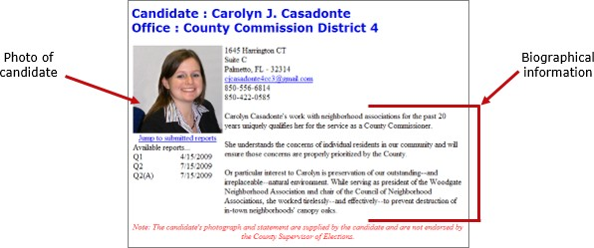

A photo and text about the candidate or committee are nice to have, but they are not required. If you don’t provide them, here is what voters will see:
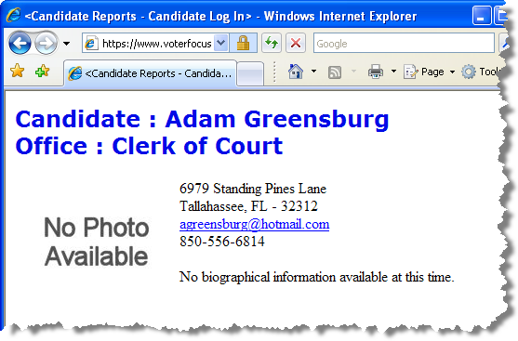

The item in the photo area need not be a photograph. Committees might prefer to show their logo instead. But the file placed in this area must be a JPEG file (a file with the 3-character extension JPG).
The system won’t accept a JPEG file that’s larger than 500 KB. It’s best to use an even smaller file, if you can. Smaller files display more quickly to website visitors, especially if a visitor has a slow Internet connection.
Note: Images with large dimensions (that is, large pixel sizes) might not display properly in certain older browsers.

Upload a Photo
- On the main (Report List) page, click the yellow button to open the Candidate/Committee Bio page.
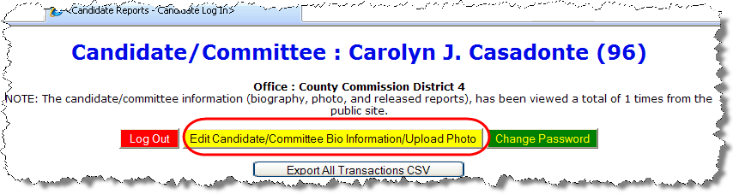
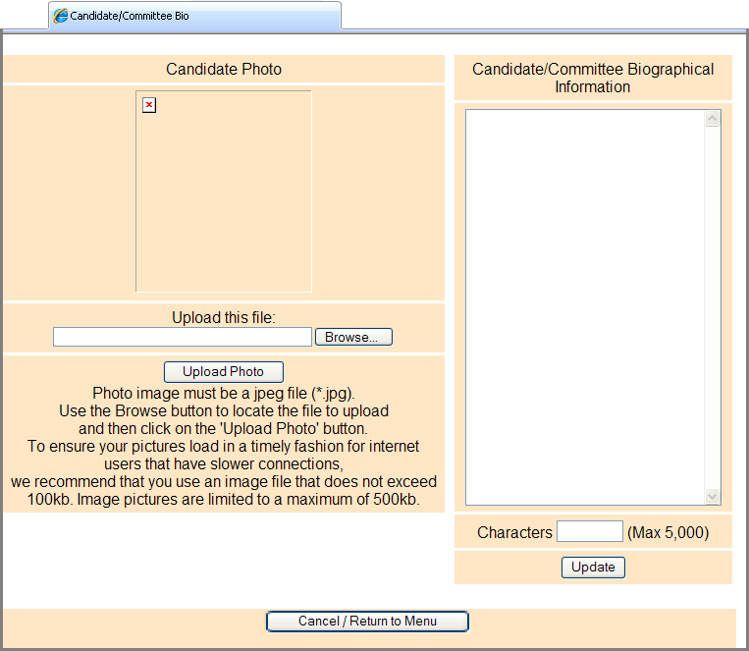

- Click Browse and navigate to the JPEG file you want to use. Then click Upload Photo.
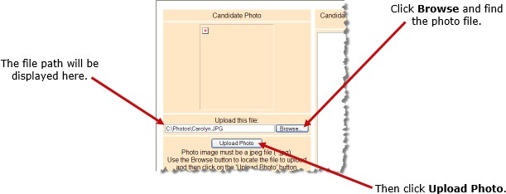

When the file has copied to the system, you’ll see this message along with the photo file:
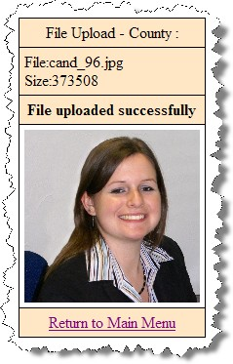

- Click Return to Main Menu to return to the Report List.

Enter Candidate or Committee Text
- On the main (Report List) page, click the yellow button to open the Candidate/Committee Bio page.

In the Candidate/Committee Biographical Information pane, type the information you want to display to voters. You can enter up to 5,000 characters. The number of characters you have entered displays in the Characters box. When you are finished, click Update.
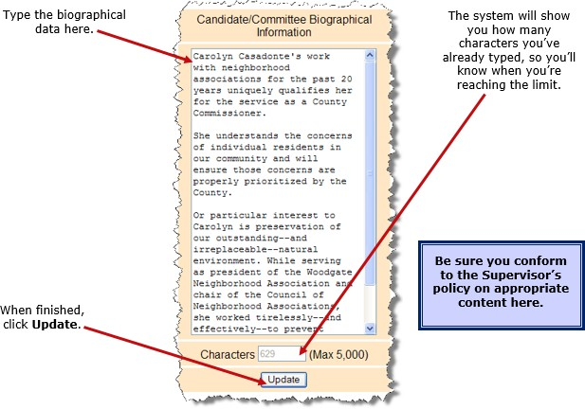

Note: When a candidate updates their bio for the first time, they will need to remove any html elements that might have been entered before the change. If no html elements were added then updates will happen as normal.

After Your Updates
If you ever want to change the photo or bio, just return to the Candidate/Committee Bio page and upload a different photo or edit the bio text.
To see how your photo and bio appear to voters, enter the address in your web browser, replacing <county> with your county name:
https://www.voterfocus.com/ws/WScand/candidate_pr.php?c=<county>
You might not see your photo and bio immediately. Your county might reserve the right to review your information before it is released to the public on their website. Check with the elections office for your county’s policy on this.

Reset Password
If you forget your password, you can simply reset it by clicking the Forgot Password link on the Log In page.
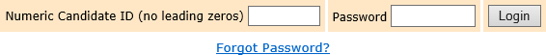

On the Candidate Forgot Password page, enter your Candidate ID number and click the
Reset Password button.

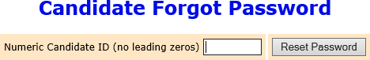

An email like the one below will be sent to the email address associated with your account. Click the link provided in the email.
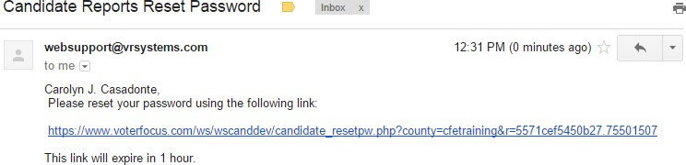

Note: If there is no email address associated with your Candidate ID, you’ll need to contact your elections office.
On the Candidate Reset Password page, enter and reenter the new password, and then click Reset Password. The password can be up to 12 characters—letters and/or numbers—and is case-sensitive.
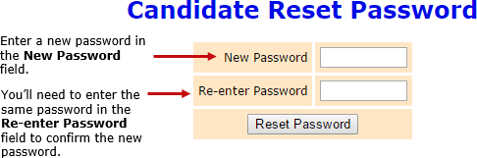

Change a Password or PINs
You can change the password assigned to you by the elections office. A password can be any combination of letters and numbers.
If your county required electronic filing of reports, your campaign has been issued PINs for the candidate and treasurer. You can also change these PINs, if you wish.

Change your password:
- On the Report List, click Change Password/PINs.
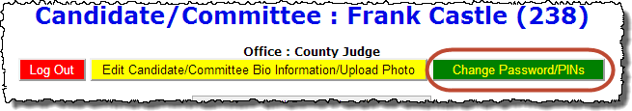

- In the Enter Old Finance System Access Password field, enter your current password. This step is required, even if you are only changing one or both PINs.
- To create a new password, enter and reenter it in the two fields provided for the new password. The password can be up to 12 characters—letters and/or numbers—and is case-sensitive. If you don’t want to change your password, don’t make any changes to the password fields.
- If you want to change a PIN, enter and reenter the new PIN in the two fields provided for the new PIN. Then enter your new password in the other two fields.
- Click Change Password/PINs when you are finished.

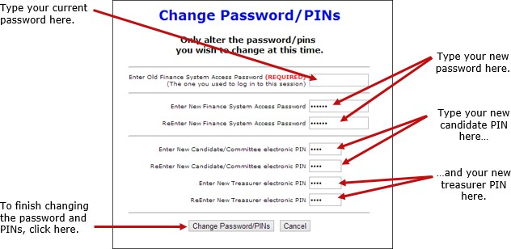

From now on, you will log on with your new password.
If you set up the Candidate Log In page to automatically fill in your password, you must retype the password there the next time you log in. When you do, you might see this message:

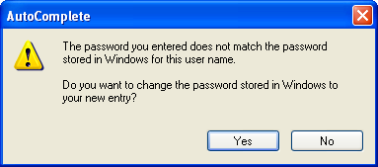

Simply click Yes to proceed into the Campaign Financial Reporting system.
Should you forget your new password, see the instructions for resetting a password. If you forget your PINs, contact the elections office. They will be able to retrieve them for you.

Log Out of the System
When you are finished with a session on the Campaign Financial Reporting system, be sure to log out so that unauthorized persons cannot modify your report data.

Log out of the system:
On the Report List, click Log Out.
